PYTHON VARIABLE

1-Introduction to python
2-Variable in python
- a variable is a name that refers to a memory location where a value is stored.
- a variable is a container for data.
3-Charcteristic of variable
- Dynamic Typing: no need to declare any variable like (int, float, string)
- No Explicit Declaration: Just assign a value, and Python will automatically create the variable
- Mutable: You can change the value of a variable as many times as you need during the execution of your program
4- Rules to define variable in python
- Must start with a letter (a-z, A-Z) or an underscore (_).
- Can contain letters, digits (0-9), and underscores, but cannot start with a digit.
- Case-sensitive: age, Age, and AGE are different variables.
- Cannot be a Python keyword (e.g., True, False, if, for, class, etc.).
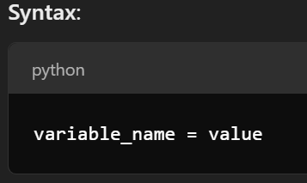
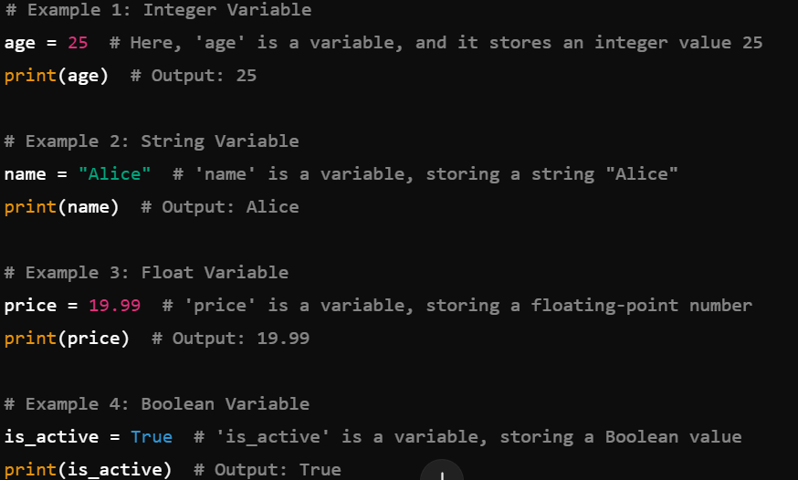
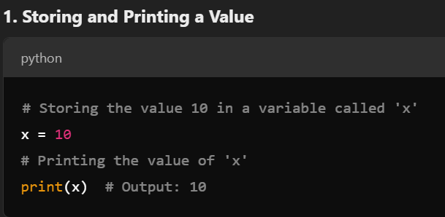
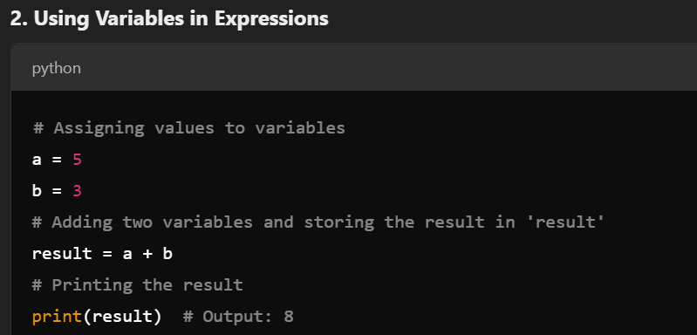
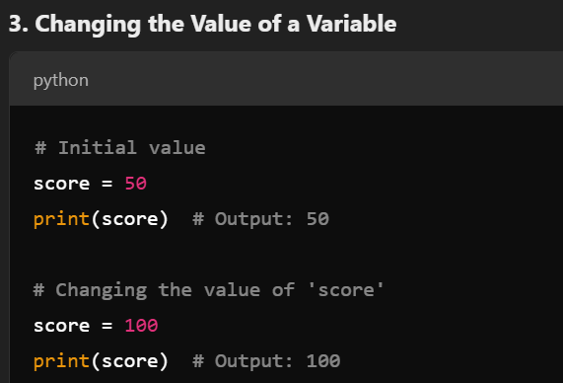
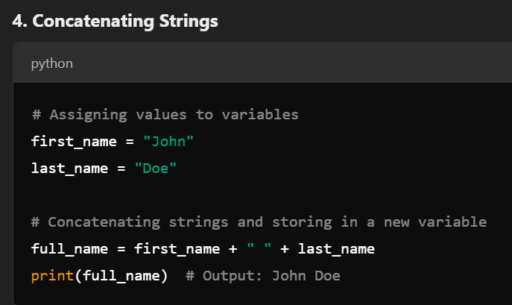

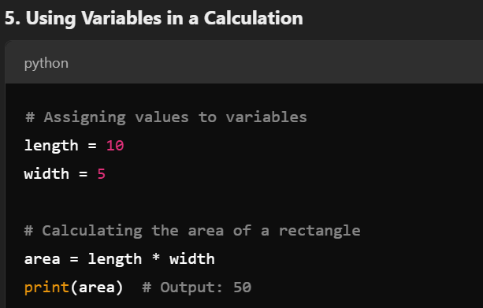
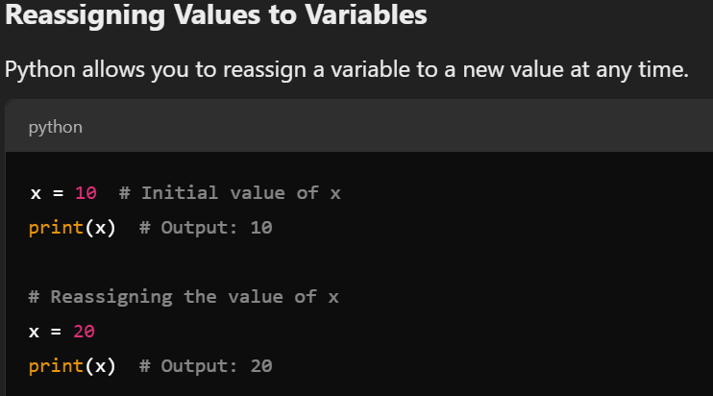

Final Notes:
- Variables can store any type of data, including numbers, strings, lists, dictionaries, objects, etc.
- Variables are dynamic, meaning their type is automatically determined by the value assigned to them, and they can change type during execution.

